### Code Smell 2: Data Class

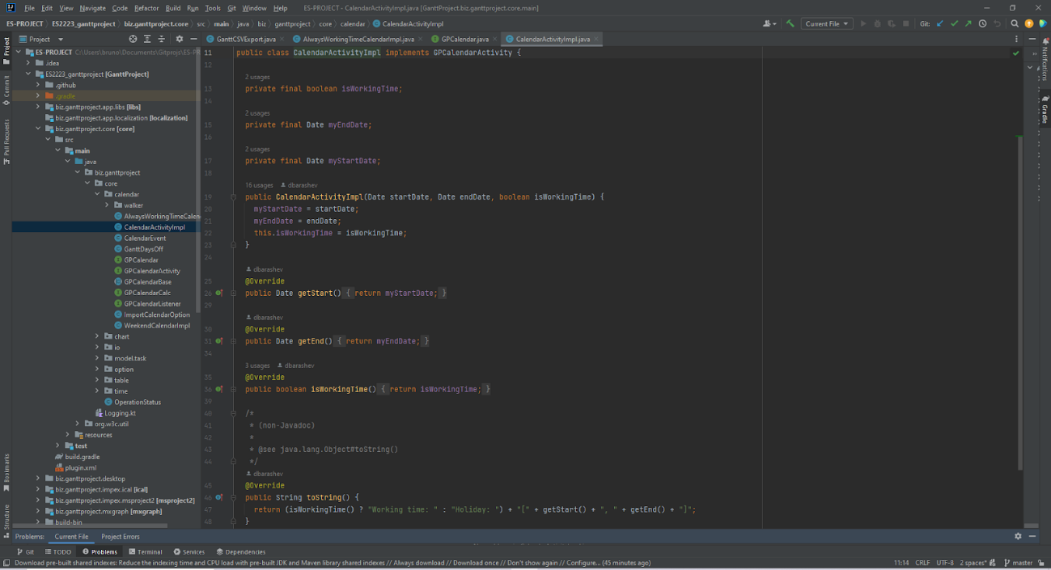

**Location of the code smell from repository root:**

biz.ganttproject.core/src/main/java/biz/ganttproject/core/calendar/CalendarActivityImpl.java

**Explanation:**

The CalendarActivityImpl.java class is too small and is only used to store, having no real functionality. This is a code smell known as Data Class.

**Refactoring proposal:**

This class may not be needed if its only functionality is to store data. Alternatively, some functionality could be added to it in order to make it a necessary class.